Group: ITP_24_B4_T048

Activity 1

Team Members

1. Jayasekara M.P.S.S - IT22580344
2. Chandrasekara C.M.P.V - IT22286246
3. Wijewantha H.D.C - IT22137128
4. Nathasha K.D.S - IT22230638
5. Tharuka M.S - IT22101242
6. Silva M.W.P.R.K - IT22124876
7. Abeysekara.W.R.G.M - IT22271150
8. Jayasundara J.M.T.P - IT22281128

**Onion Diagram**

**Stake holders**

1. Renters
2. Vehicle Owner
3. Driver
4. Vehicle Manager
5. Driver manager
6. Payment manager
7. Hr manager
8. Maintenance manager
9. Customer manager
10. System manager

**Hire and rental Management system**

**Booking Management system**

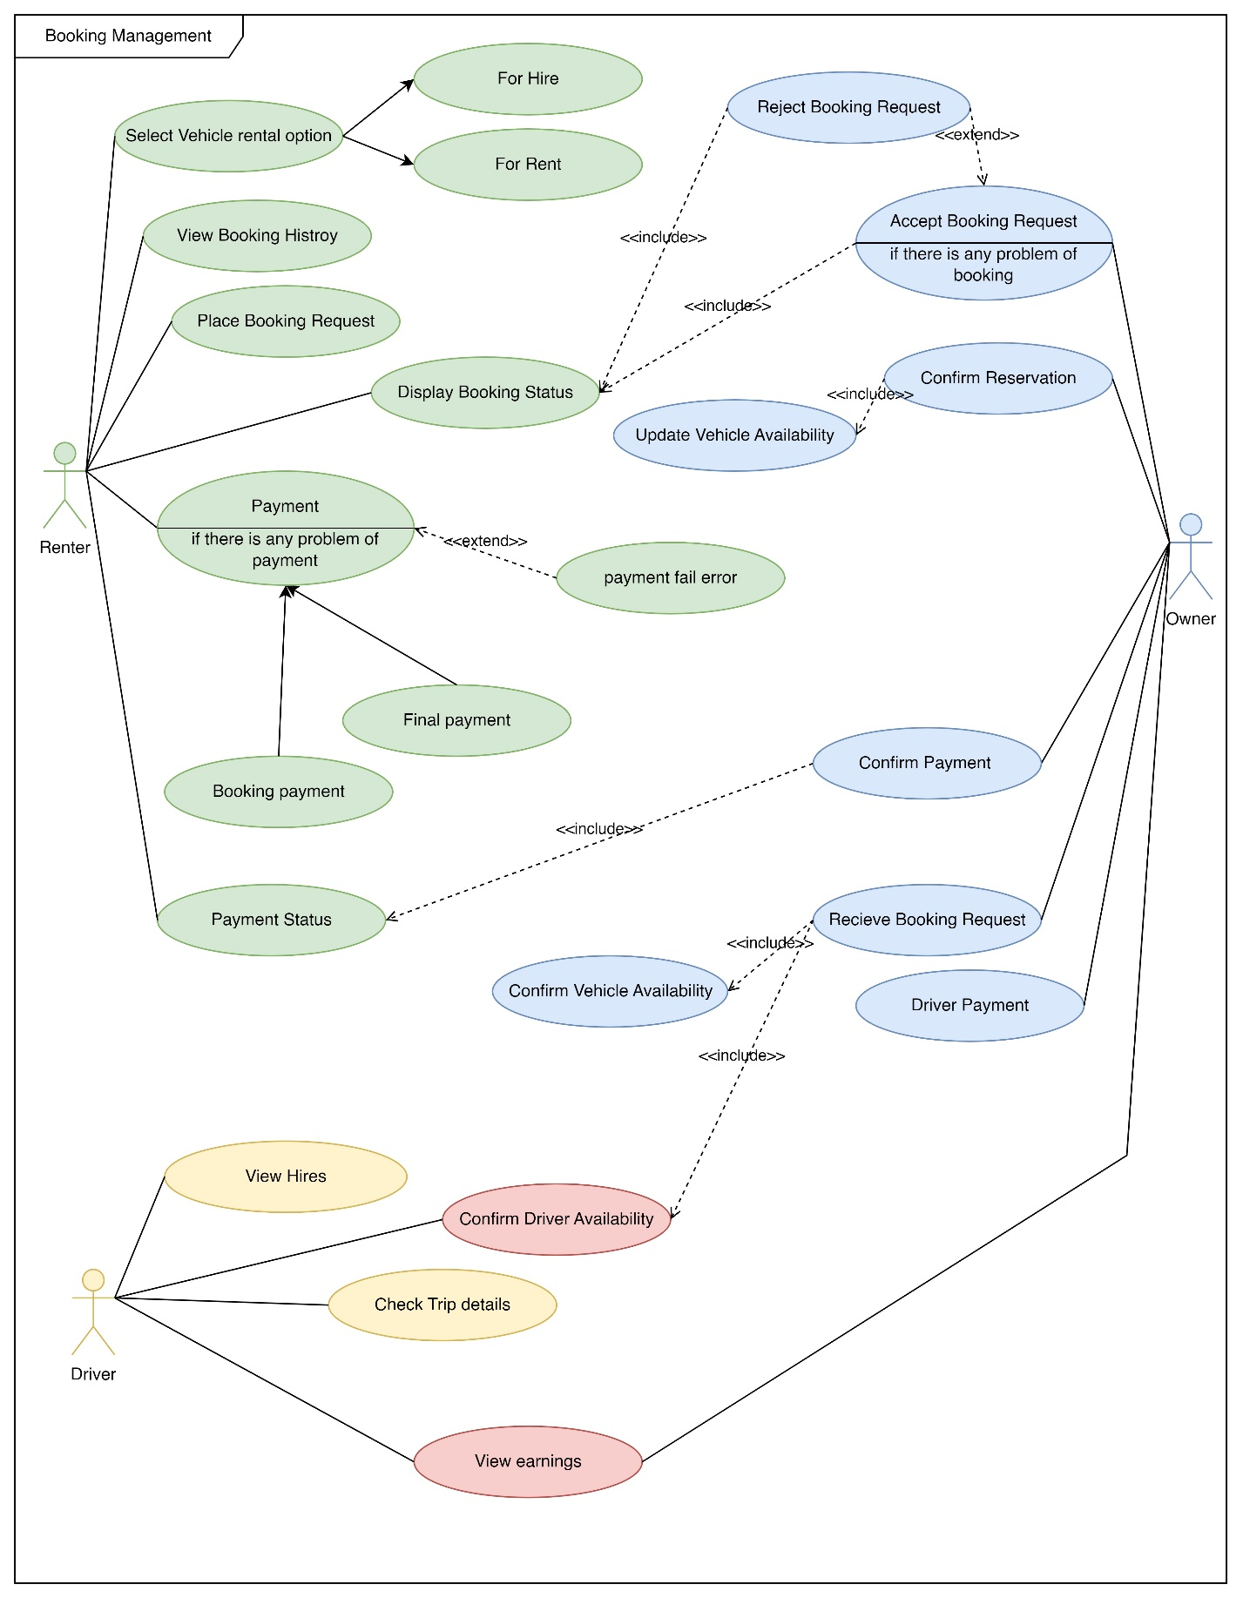

**Booking Management Use case Diagrams**

|  |  |  |
| --- | --- | --- |
| Name | Booking a vehicle for **hire** | |
| Summary | Renter books a vehicle for a hire | |
| Priority | 2 | |
| Preconditions | Renter must login to the system | |
| Postconditions | Renter can have reservation confirmation | |
| Primary Actor(s) | Renter , Vehicle Owner , Driver | |
| Main Scenario | **Step** | **Action** |
|  | 1 | Renter selects the booking type as hire |
|  | 2 | Renter filter and select a vehicle based on vehicle type and price ,etc. |
|  | 3 | Renter visits vehicle details page |
|  | 4 | Renter checks vehicle availability |
|  | 5 | Renter fills the request booking form with necessary information such as rental duration, pickup and return location, etc. |
|  | 6 | Renter clicks on request booking button |
|  | 7 | Vehicle owner confirms vehicle availability |
|  | 8 | Vehicle owner check driver availability |
|  | 9 | Vehicle owner accepts booking request |
|  | 10 | System notify renter with booking payment |
|  | 11 | Renter pays the booking payment |
|  | 12 | System shows booking successful msg to renter |
|  | 13 | System notifies vehicle owner about booking payment |
|  | 14 | Vehicle owner confirms booking payment |
|  | 15 | Vehicle owner reserve vehicle for renter |
|  | 16 | Vehicle owner updates vehicle availability |
|  | 17 | System generates full payment bill after trip |
|  | 18 | Renter pays full payment |
|  | 19 | Renter gives rating to vehicle and driver |
|  | 20 | Vehicle owner confirm payment received |
|  | 21 | Vehicle owner pays to driver |
|  | 22 | Driver confirms payment |
| Extensions | **Step** | **Action** |
|  | 7a | if the vehicle is not available, the system notifies the renter about the unavailability and suggests other available vehicles. |
|  | 8a | if the driver is not available, the vehicle owner attempts to assign another driver |
|  | 8b | If the vehicle owner fails to find an alternative driver, they inform the system about the vehicle’s unavailability. |
|  | 11a | if the payment fails, the system notifies the renter about the failed payment and asks them to try again or use a different payment method. |

**User Story : Booking a Vehicle for Hire**

As a Renter,

I want to log into the system,

So that I can book a vehicle for hire.

As a Renter,

I want to select the booking type as hire,

So that I can proceed with the booking process.

As a Renter,

I want to filter and select a vehicle based on vehicle type, price and location

So that I can choose the best vehicle for my needs.

As a Renter,

I want to check the vehicle's availability,

So that I can ensure the vehicle is available for hire.

As a Renter,

I want to fill out the request booking form with necessary information,

So that I can request a booking for the vehicle.

As a Vehicle Owner,

I want to confirm the vehicle's availability,

So that I can accept or reject the booking request.

As a Vehicle Owner,

I want to check the driver's availability,

So that I can ensure a driver is available for hire.

As a Vehicle Owner,

I want to accept the booking request,

So that I can reserve the vehicle for the renter.

As a Renter,

I want to pay the booking payment,

So that I can confirm my booking.

As a Renter,

I want to receive a booking successful message,

So that I know my booking has been successful.

As a Vehicle Owner,

I want to confirm the booking payment,

So that I can finalize the booking.

As a Vehicle Owner,

I want to update the vehicle's availability,

So that the system reflects the current availability of the vehicle.

As a Renter,

I want to pay the final payment after hire.

So that I can complete my payment

As a Vehicle Owner

I want to receive final payment.

So that I can return vehicle from renter

As a Vehicle Owner

I want to pay the driver.

So that driver can have the payment.

As a Driver

I want to confirm payment.

So that Owner can know to payment is successful.

As a Vehicle Owner

I want to change vehicle availability status.

So that other Renters can hire or rent the vehicle.

|  |  |  |
| --- | --- | --- |
| Name | Booking a vehicle for **rent** | |
| Summary | Renter books a vehicle for a rent | |
| Priority | 2 | |
| Preconditions | Renter must login to the system | |
| Postconditions | Renter can have reservation confirmation | |
| Primary Actor(s) | Renter, Vehicle Owner | |
| Main Scenario | **Step** | **Action** |
|  | 1 | Renter selects the booking type as rent |
|  | 2 | Renter filter and select a vehicle based on vehicle type and price,etc. |
|  | 3 | Renter visits vehicle details page |
|  | 4 | Renter checks vehicle availability |
|  | 5 | Renter fills the request booking form |
|  | 6 | Renter clicks on request booking button |
|  | 7 | Vehicle owner confirms vehicle availability |
|  | 8 | Vehicle owner accepts booking request |
|  | 9 | System notify renter with booking payment |
|  | 10 | Renter pays the booking payment |
|  | 11 | System shows booking successful msg to renter |
|  | 12 | System calculates amount of deposit and display to renter |
|  | 13 | System display required documents for reserve vehicle |
|  | 14 | System notifies vehicle owner about booking payment |
|  | 15 | Vehicle owners confirm booking payment |
|  | 16 | Renter pays the deposit and reserve vehicle |
|  | 17 | Vehicle owner updates vehicle availability |
|  | 18 | System Calculates Final Payment after renter returns vehicle back |
|  | 19 | System Reduces Final Payment from Deposit |
|  | 20 | Owner returns remaining deposit to renter |
| Extensions | **Step** | **Action** |
|  | 7a | if the vehicle is not available, the system notifies the renter about the unavailability and suggests other available vehicles. |
|  | 10a | if the payment fails, the system notifies the renter about the failed payment and asks them to try again or use a different payment method. |
|  | 13a | if the renter does not have the required documents for reserving the vehicle, the system informs the renter about the missing documents and asks them to provide them. |
|  | 18a | if the vehicle is returned with damage, the system adds a damage fee to the final payment. |
|  | 18b | if the vehicle is returned late, the system adds a late fee to the final payment. |

**User Story: Booking a Vehicle for rent**

As a Renter,

I want to log into the system,

So that I can book a vehicle for rent.

As a Renter,

I want to select the booking type as rent,

So that I can proceed with the booking process.

As a Renter,

I want to filter and select a vehicle based on vehicle type and price,

So that I can choose the best vehicle for my needs.

As a Renter,

I want to check the vehicle's availability,

So that I can ensure the vehicle is available for rent.

As a Renter,

I want to fill out the request booking form,

So that I can request a booking for the vehicle.

As a Vehicle Owner,

I want to confirm the vehicle's availability,

So that I can accept or reject the booking request.

As a Vehicle Owner,

I want to accept the booking request,

So that I can reserve the vehicle for the renter.

As a Renter,

I want to pay the booking payment,

So that I can confirm my booking.

As a Renter,

I want to receive a booking successful message,

So that I know my booking has been successful.

As a Vehicle Owner,

I want to confirm the booking payment,

So that I can finalize the booking.

As a Renter

I want to pay the full deposit for the vehicle

So that I can ren the vehicle without driver

As a Renter

I want to submit all required documentations

So that I can prove my self to vehicle owner.

As a vehicle owner

I want to confirm deposit and required documentations.

So that I can decide the renter can trusted or not

As a Vehicle Owner,

I want to update the vehicle's availability as booked.

So that other renters can’t book this vehicle until it available.

As a renter

I want to return vehicle after reserved time.

So that I can return deposit

As a Vehicle Owner

I want to calculate the cost and reduce it from deposit.

And return remaining deposit to renter.

As a vehicle Owner

I want to update vehicle availability,

So other renters can hire or rent this vehicle again.

**Functional Requirements:**

The system should allow the renter to log in.

The system should allow the renter to select the booking type (hire or rent).

The system should allow the renter to filter and select a vehicle based on vehicle type, price, etc.

The system should display vehicle details to the renter.

The system should allow the renter to check vehicle availability.

The system should allow the renter to fill a request booking form with necessary information.

The system should allow the vehicle owner to confirm vehicle availability.

The system should allow the vehicle owner to check driver availability (for hire).

The system should allow the vehicle owner to accept the booking request.

The system should notify the renter with booking payment details.

The system should allow the renter to pay the booking payment.

The system should show a booking successful message to the renter.

The system should notify the vehicle owner about the booking payment.

The system should allow the vehicle owner to confirm the booking payment.

The system should allow the vehicle owner to reserve the vehicle for the renter.

The system should allow the vehicle owner to update vehicle availability.

**Non-Functional Requirements:**

The system should be user-friendly, with an intuitive interface for both renters and vehicle owners and drivers.

Security, usability, performance, reliability, scalability, compatibility

The system should be able to send notifications in real-time.

The system should be available 24/7 with minimal downtime.

The system should ensure the privacy and security of user data.

The system should be easy to use and navigate for all types of users, vehicle renters and vehicle owners.

**Technical Requirements:**

The system should be web-based, accessible via any modern web browser.

The system should be built using a reliable and scalable tech stack.

The system should use a secure database for storing user data.

The system should be hosted on a secure and reliable web server.

**Vehicle Owner Management System**

|  |  |  |
| --- | --- | --- |
| **Name** | Vehicle Owner Management System | |
| **Summary** | Vehicle owner logging in and adding vehicles/drivers to their profile within the system | |
| **Priority** | 01 | |
| **Pre-conditions** | Owner must be registered and has access rights to add vehicles/drivers to their profiles | |
| **Post conditions** | The vehicle is successfully added to the owner’s profile | |
| **Primary actors** | Vehicle Owner | |
| **Trigger** | The vehicle owner initiates the process of adding a vehicle | |
| **Main Scenario** | **Step** | **Action** |
|  | The vehicle owner navigates to the registration page and create a profile and login to the system using credentials. |
|  | Upon logging in, the owner has to fill vehicle details to add vehicles. |
|  | If assigning a driver, owner add driver details to the profile. |
|  | If owner needs to update vehicle/driver details, he can make necessary changes. |
|  | If owner needs to delete vehicle/driver details, select the option to delete. |
|  | After adding vehicles and drivers, the system sends notifications to the owner for new bookings and maintenance reminders. |
|  | The owner reviews the notifications and click ‘OK’ button to confirm the booking. |
|  | The system displays a success message to the owner |
| **Extensions** | **Step** | **Branching Actions** |
| 1a. | System notify wrong credentials. |
| 4a. | The system verifies the updates and notifies relevant parties. |
| 5a. | The system prompts for confirmation and update the database |

**User story** : Vehicle owner logging in and adding vehicles/drivers to their profile

As a vehicle owner,

I want to log into the system to manage my vehicles and drivers efficiently.

Once logged in, I should be able to easily add new vehicles or drivers to my profile, providing essential details such as vehicle type, registration information, and driver information.

As a vehicle owner,

I need the option to update vehicle and driver information , ensuring that my fleet records are always current.

As a vehicle owner,

If a vehicle or driver is no longer part of my fleet, I want the capability to remove them from my profile.

As a vehicle owner,

I expect to receive timely notifications about booking requests for my vehicles, ensuring I stay informed about my fleet’s usage.

As a vehicle owner,

Additionally, I’d like to receive confirmations and updates regarding accepted booking requests for my vehicles.

**Functional Requirements:**

**-** Allowvehicle owners to create profiles on the platforms

**-** If the vehicle is registered with a driver, allow owners to provide driver details

**-** Provide a dashboard for owners to view and manage booking their vehicles

**-** Allow owners to access financial reports and histories including rental earnings

**-** Enable owner to receive alerts and notifications for new booking requests, upcoming maintenance tasks and other important updates

**Non-Functional Requirements:**

-Design a user-friendly interface for vehicle owners to easily register their vehicles.

-Ensure compatibility with various devices, browsers.

-Ensure compliance with local regulations and licensing requirements for vehicle rental operations.

-Ensure high system availability to allow vehicle owners to register their vehicles and manage rental activities.

**Technical Requirements:**

The system should be web-based, accessible via any modern web browser.

The system should be built using a reliable and scalable tech stack.

The system should use a secure database for storing user data.

The system should be hosted on a secure and reliable web server.

**Vehicle Maintenance Management system**

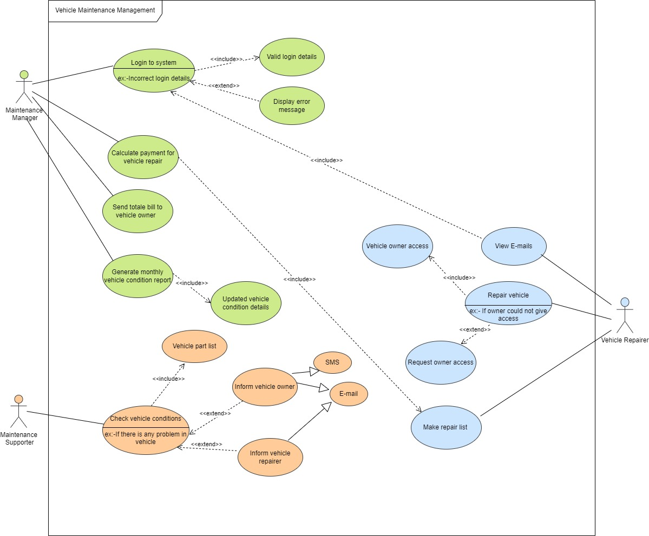

**Vehicle Maintenance Management**

|  |  |  |
| --- | --- | --- |
| **Name** | Vehicle Maintenance Management | |
| **Summary** | Maintenance vehicle conditions | |
| **Priority** |  | |
| **Pre-Conditions** | Maintenance Manager should be logged into system | |
| **Post-Conditions** | Vehicle owner has received an email with repair bill | |
| **Primary Actor(s)** | Vehicle Maintenance Manager | |
| **Main Scenario** | **Step** | **Action** |
| 1 | Maintenance Manager login to system |
| 2 | System validates login credentials by connecting with its vehicle maintenance database |
| 3 | System displays maintenance management dashboard |
| 4 | Maintenance Supporter check conditions of vehicle |
| 5 | Maintenance Supporter inform to Vehicle Repairer about vehicle |
| 6 | Maintenance Manager generates monthly vehicle conditions report |
| 7 | Vehicle Repairer check e-mails and repair vehicle |
|  | 8 | Vehicle Repairer make repair list |
|  | **Step** | **Action** |
| **Extensions** | 1a | System displays the login error message and asks to login again |
|  | 4a | Maintenance Supporter inform about problem to vehicle owner and vehicle repairer via E-mail and SMS |
|  | 7a | Vehicle Repairer request access form vehicle owner for repair the vehicle |

**User Story : Vehicle Maintenance Management**

As a Maintenance Manager,

I want to log into the system,

So that I can see monthly report for maintenance vehicles.

As a Maintenance Manager,

I want to select vehicles,

So that I can check their conditions.

As a Maintenance Manager,

I want to know vehicle location,

So that I can choose nearest Maintenance Supporter for check selected vehicle.

As a Maintenance Supporter,

I want to check the vehicle's conditions,

So that I can ensure the vehicle is ready for hire.

As a Maintenance Supporter,

I want to fill out vehicle part list with condition information,

So that I can inform to Vehicle Repairer for repair vehicle.

As a Vehicle Repairer,

I want to confirm the repair request,

So that I can repair the vehicle .

As a Vehicle Repairer,

I want to make repair list,

So that I can send repair list to Maintenance Manager .

As a Maintenance Manager,

I want to calculate the total amount,

So that I can send the total bill for repair vehicle to Vehicle Owner.

**Functional Requirements:**

The system should allow the Maintenance Manager to log in.

The system should allow the Maintenance Manager to select the vehicles for check conditions.

The system should allow the Maintenance Manager to know the vehicle location.

The system should display vehicle details to the Maintenance Manager.

The system should allow the Maintenance Supporter to check vehicle conditions.

The system should allow the Maintenance Supporter to fill the vehicle part list.

The system should allow the Vehicle Repairer to confirm request of repair .

The system should allow the Vehicle Repairer to make repair list.

The system should allow the Maintenance Manager to calculate total amount.

The system should notify the Vehicle Owner with repair payment details.

The system should allow the Vehicle Owner to pay the repair payment.

The system should show a payment successful message to the Vehicle Owner. **Non-Functional Requirements:**

The system should be user-friendly, with an intuitive interface for both Maintenance Manager and Vehicle Owners and Vehicle Repairer.

Security, usability, performance, reliability, scalability, compatibility

The system should be able to send notifications in real-time.

The system should be available 24/7 with minimal downtime.

The system should ensure the privacy and security of user data.

The system should be easy to use and navigate for all types of Vehicle Repairer and Vehicle Owners.

**Technical Requirements:**

The system should be web-based, accessible via any modern web browser.

The system should be built using a reliable and scalable tech stack.

The system should use a secure database for storing user data.

The system should be hosted on a secure and reliable web server.

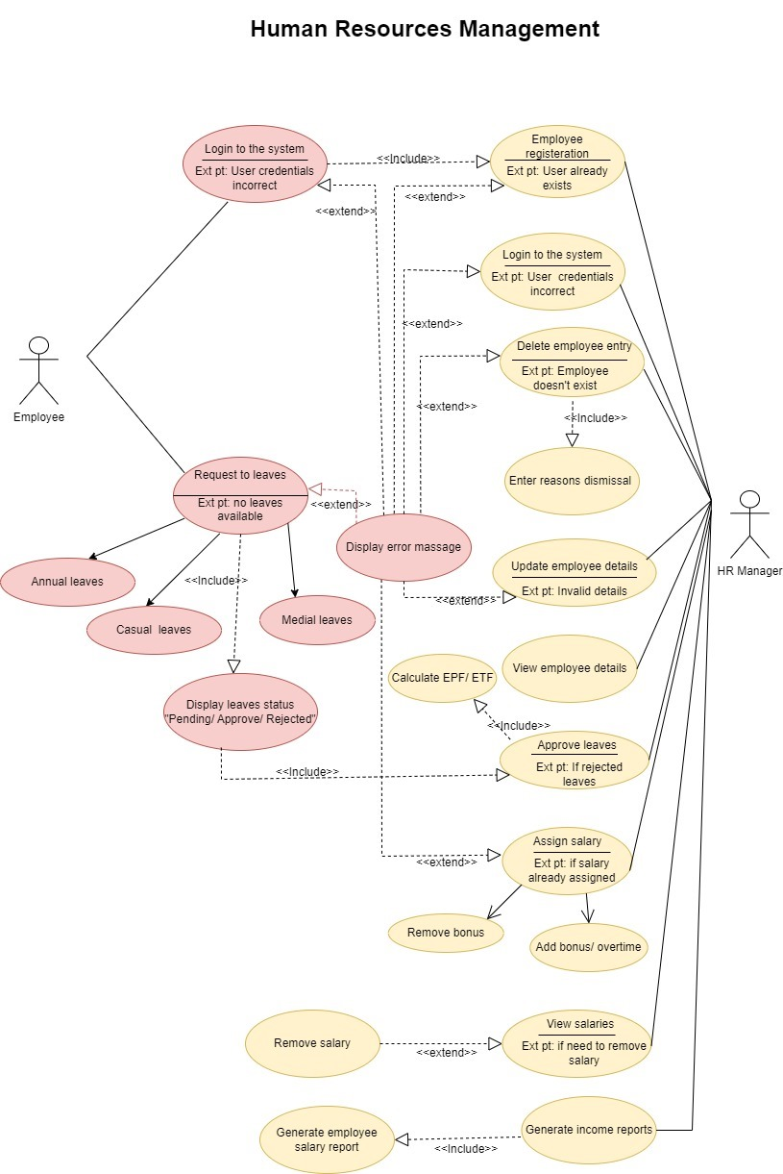

|  |  |  |
| --- | --- | --- |
| Use Case Name | Register Employee | |
| Use Case Summary | Registering a New Employee in System | |
| Priority | 3 | |
| Primary Actor | HR Manager | |
| Pre-Conditions | HR Manager login to the system | |
| Post-Conditions | The new employee's information is successfully stored in the HR management system. | |
| Trigger | Adding a new worker to the organization | |
|  | **Step** | **Action** |
|  | 1 | the HR Manager, logs into the System using username and password. |
|  | 2 | The system connects to its user database to verify the login credentials. |
|  | 3 | The system allows access to the HR Management dashboard |
|  | 4 | On the dashboard, notices an option to "Register New Employee" and clicks on it. |
|  | 5 | A new employee registration form is shown by the system. |
|  | 6 | HR chooses whether to register an employee as a "Full-Time," "Part-Time," or "Contractor." |
|  | 7 | The system dynamically shows relevant field according to the employee type |
| **Main Scenario** | 8 | HR Manager enters employee details (Name, Address, NIC, Gender etc.) and uploads employee image. |
|  | 9 | The HR manager inputs the worker's job details, such as title, start date, pay, and manager. |
|  | 10 | The HR manager verifies the entered information for accuracy. |
|  | 11 | Once verified, the HR manager submits the registration form. |
|  | 12 | The system enters the employee's information and registration number (employee ID) into the employee database after successful validation. |
|  | 13 | system displays a message as successfully registered. |
|  | 14 | HR manager clicks “OK” button. |
|  | 15 | System directs to the employee management dashboard. |
| **Extensions** | **Step** | **Actions** |
|  | 1.a | Display error message for invalid credential |
|  | 8.a | System displays ’Please upload images less than “5MB”. |
|  | 10.a | If any errors are found during data validation, the system prompts the HR manager to correct them before proceeding. |

Functional Requirements

* Employee data, such as names, addresses, phone numbers, job titles, and employment status, should be inputted and stored by the HR manager.
* Employee data should be able to be updated and deleted by the HR management as needed.
* The system should provide options for the HR manager to approve or reject leave requests.
* The HR manager should be able to enter basic salary, bonuses, and overtime (OT) payments into the system.
* Allow the monthly reports, such as net income and employee salary reports, to be generated by the HR manager.

HR Manager’s Story

* As a HR Manager,

I want to be able to easily add new workers to the system and record all of their pertinent information, including start date, job role, contact information, and personal details. This will make it possible for me to onboard new hires quickly and guarantee that all relevant information is available.

* As a HR Manager,

I must have the ability to add, remove, or alter job titles, personal information, and other pertinent facts from employee records as needed. This guarantees that the personnel database appropriately has the most recent data.

* As a HR Manager,

I want to be able to handle employee departures by recording the reason for dismissal when an employee resigns or is terminated.

* As a HR Manager,

I need the ability to set aside money and adjust it in response to things like bonuses and overtime. This allows me to produce thorough wage records at the conclusion of every month.

Driver Management System

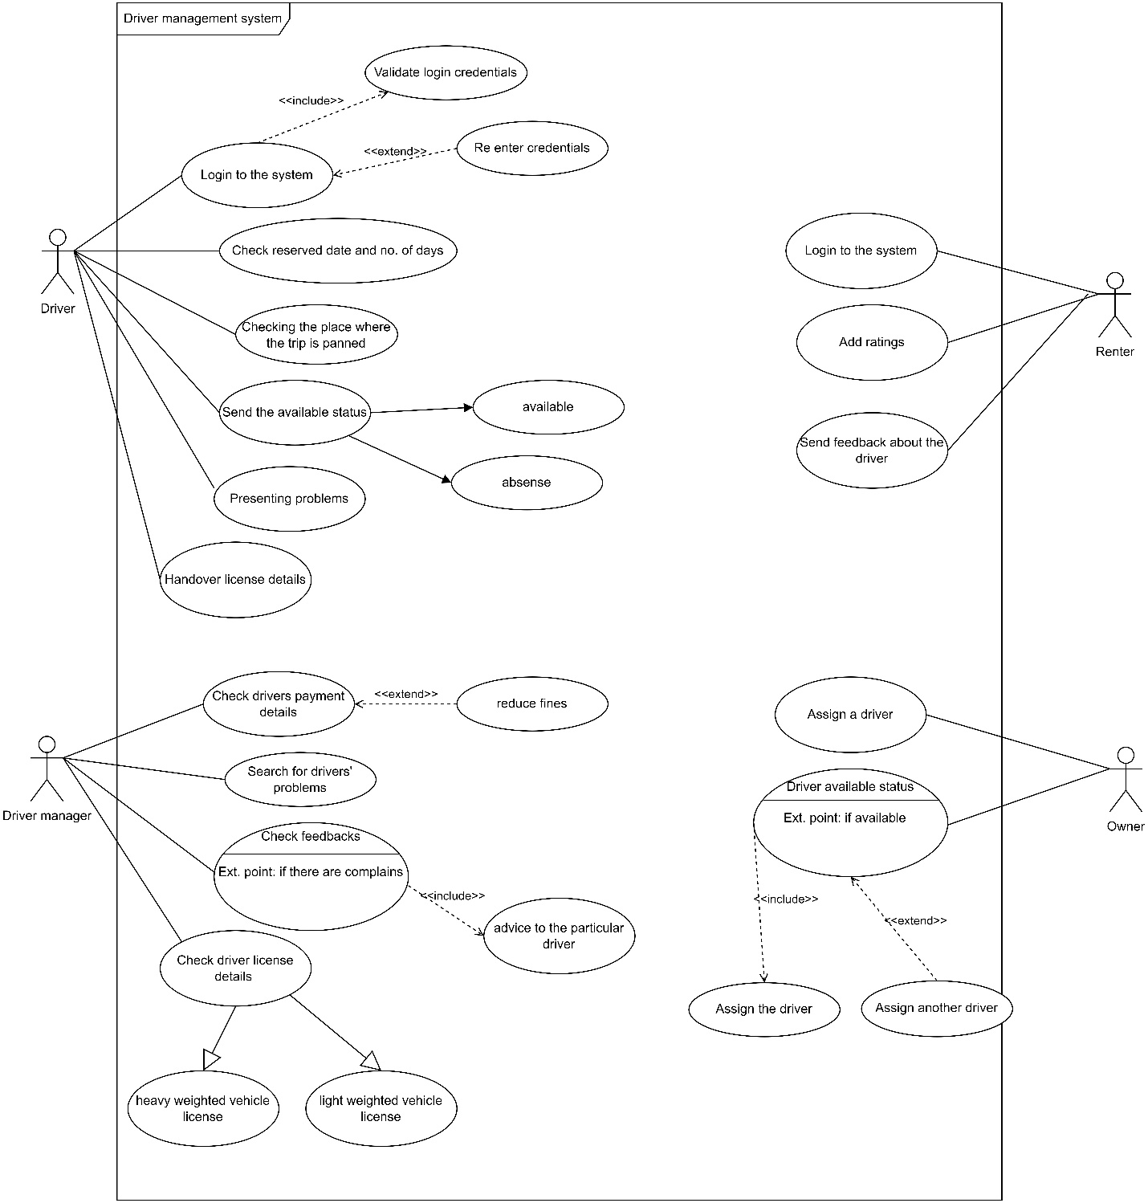

|  |  |  |
| --- | --- | --- |
| Name | Driver Management System | |
| Summary | Assign and manage drivers to the vehicles which are rented by a renter. | |
| Priority | 04 | |
| Preconditions | Driver should register to the system. | |
| Postconditions | Assigned driver will drive the trip. | |
| Primary Actor(s) | Renter, Vehicle Owner , Driver | |
| Main Scenario | **Step** | **Action** |
| 01 | Driver registers in the driver management system. |
| 02 | Owner checks for the reservations. |
| 03 | Owner assigns a driver to the trip. |
| 04 | Driver checks the date, no. of days and the location that the trip is planned. |
| 05 | Driver sends the status whether the date was free or busy. |
| 06 | Owner checks the driver availability status. |
| 07 | Drivers can handover their license details to the system. |
| 08 | Driver manager checks and separate the light weighted and heavy weighted license holders. |
| 09 | Driver manager can check the payment details of the drivers. |
| 10 | Drivers can present their problems to the system. |
| 11 | Driver manager notices the problems and take necessary steps. |
| 12 | Renters can send feedback about the driver. |
| 13 | Driver manager read the feedback. |
| 14 | Customer can rate drivers. |
| Extensions | **Step** | **Action** |
|  | 1.a | If credentials are wrong driver must re-enter the credentials. |
|  | 6.a | If driver not available owner tries to assign alternative driver |
|  | 8.a | Drivers can only drive the vehicles according to their license category. |
|  | 13.a | If there are complaints, the driver manager will forward that to the particular driver. |

**A Driver Manager’s story,**

* As a driver manager, I want to handle the driver related activities. I want the ability as soon as possible. So, we can provide a faster and quality service for the customer.
* As a driver manager, I want the ability to manage user profiles. So, I can add or remove new drivers.
* As a driver manager, I would like to know the customer feedback and if there are any mistakes or faults of drivers, I may ask them to correct the mistakes.

**Functional requirements**

* **Allow drivers to register with the platform.**
* **Should be able to create and update their profiles.**
* **Provide a user-friendly interface for drivers to browse the available vehicles.**
* **Implement a feature to verify the authentication of their license.**
* **Send notifications for drivers for reservation confirmations, upcoming bookings etc.**

**Nonfunctional requirements**

* Reliability, availability, scalability, user-friendly, usability, and security
* The system should be available 24/7 with minimal downtime.
* The system should be easy to use for all types of users.
* The system should ensure the privacy and security of user data.

**Technical Requirements:**

The system should be web-based, accessible via any modern web browser.

The system should be built using a reliable and scalable tech stack.

The system should use a secure database for storing user data.

The system should be hosted on a secure and reliable web server.

**Customer management system**

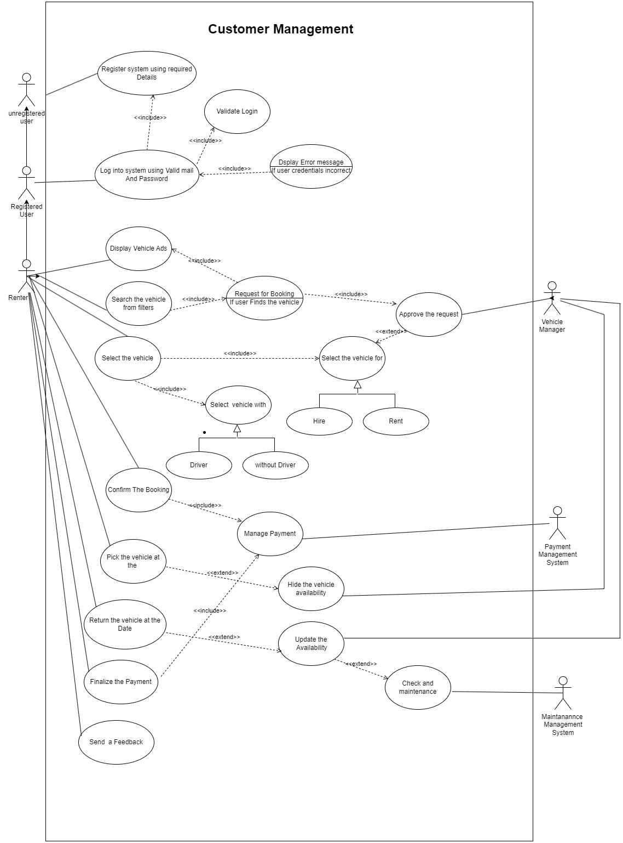

|  |  |  |
| --- | --- | --- |
| Name | Customer Management System | |
| Summary | Manage the customers activities in the system | |
| Priority | 02 | |
| Pre-Condition | Renter Must Register on the system | |
| Post-Condition | Finish the rental Process | |
| Primary Actors | Renters | |
| Trigger | Renter Search and rent a vehicle | |
| Main  Scenario | Step | Action |
| 1 | Register Into the System |
| 2 | Login Into System with valid Credentials |
| 3 | Looking For a Vehicle ads |
| 4 | Select a Suitable Vehicle |
| 5 | Request for a Booking |
| 6 | Confirm the Booking |
| 7 | Pick the vehicle On time |
| 8 | Return the vehicle |
| 9 | Finish the full Payment |
| 10 | Send A feedback |
|  | Step | Action |
|  | 1.a | If any error Occurred Retry with registering or contact admins |
|  | 2.a | If credentials are wrong display a error message and give another chances to retry |
| Extensions | 3.a | If the system won’t show the needed vehicle renter can manually select a vehicle by filtering |
|  | 3.b | When they search something it will saved in history and after time he or she can easily got that filter by a single click |
|  | 5.a | After selecting the vehicle request for a vehicle with driver or without driver and for hire or for rent |
|  | 7.a | If user want to cancel the booking user can refund 50% of deposited money when he make the booking |
|  | 8.a | If user failed to return the vehicle on time he would have to pay more . |
|  | 9.a | In the rentering time if the user had to repair the vehicle that costs will be deduct from his final payment which will be done by payment management system |
|  | 10.a | If user has a complain he can put a complain or if he has a good feedback he can put it in the System |

Functional Requirements

User Management System

* Allow User to register and create a new account and delete that account
* Show renters vehicle ads. if someone can’t find the vehicle that he want he can simply search and find that vehicle. That search result will be saved in the system and it gives ability to user easily access that search result by clicking that one.
* When the renter finds a vehicle he can request it from the system and he can manage them anytime by deleting that requests and updating them.
* We provide ability to renters edit their confirmed bookings within 24 Hours. If He wants to delete that Booking on 24 hour He can get full refund and if more thana day he can have only 50% as a refund.
* We provide a Ability to find a Driver to him If he wants when a rentering a vehicle

User stories

* As a renter I want to find a vehicle to rent or a hire when I want .sometimes I want to Have a driver with it .
* When rentering wehicle some times I want to rent it without deposits.I can bring a NIC with me and verify my identity
* I should be able to edit my bookings .
* When I requesting for a vehicle I could be able to see all the requests which I have done On the system at a one place.
* The system should me user friendly and must me easy to filter vehicles and save that filters and should have a watch list.
* As a renter System should calculate all the costs and final cost which I should pay.
* If I Have a vehicle I should be able to rent it n the system

**Reviews and complain management system**

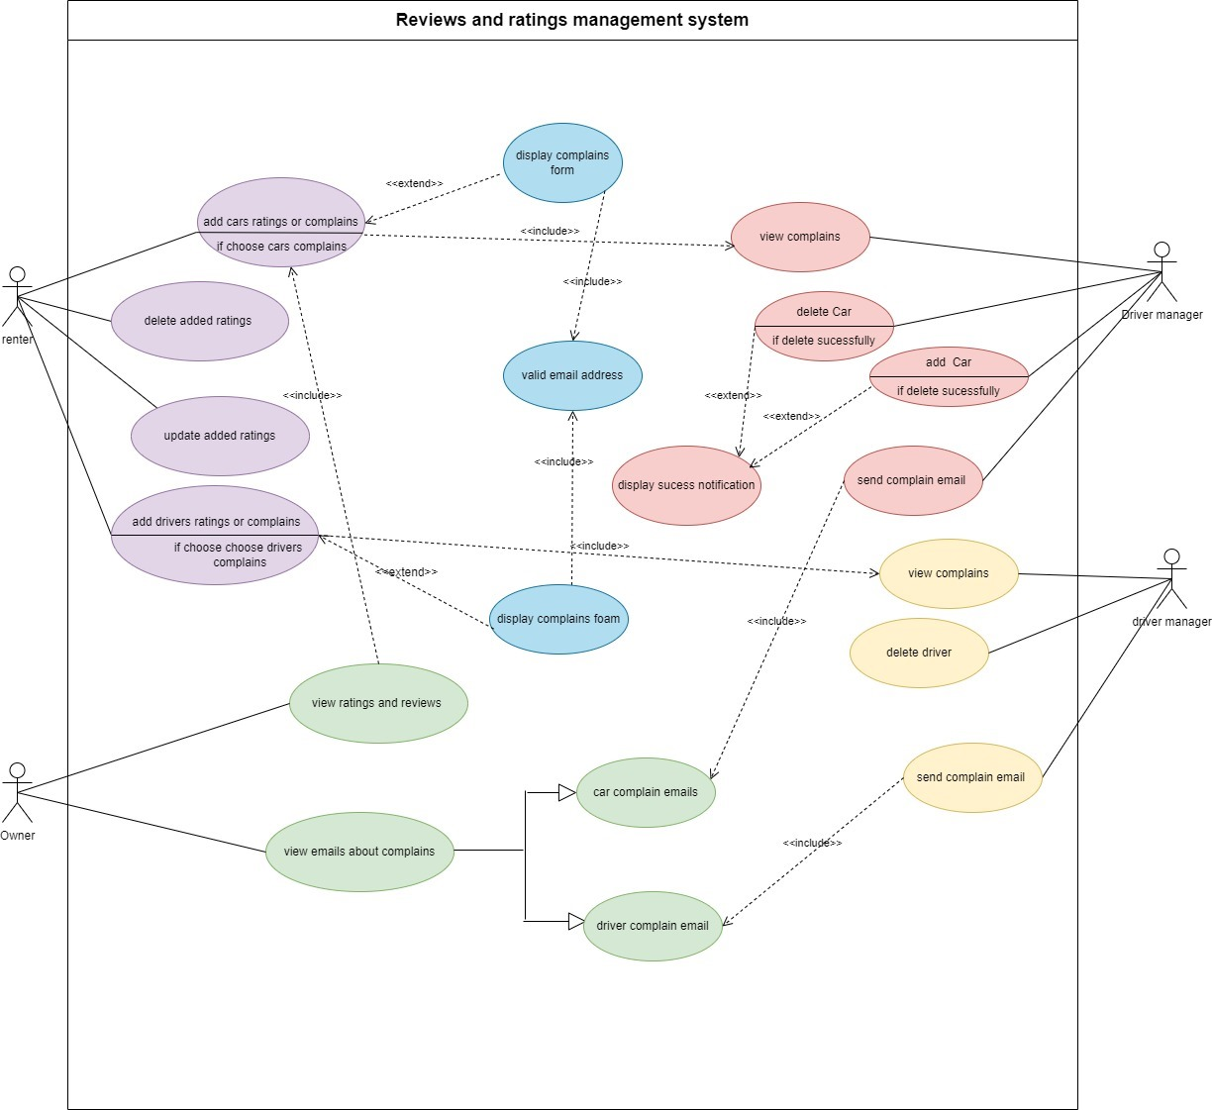

Ratings And Review Management

|  |  |  |
| --- | --- | --- |
| Name | Ratings and reviews management | |
| Summary | Manage all the Ratings, complains and reviews | |
| Priority | 01 | |
| Preconditions | User should Registered in their specific role | |
| Postconditions | User can add, delete, update reviews and ratings | |
| Primary Actor(s) | Renter | |
| Trigger | User has chosen to fill submit form and give ratings by stars | |
| Main Scenario | **Step** | |
| Main Scenario | 1 | **Action** |
| 2 | The user clicks the “Feedback” button. |
| 3 | The system displays the feedback options(reviews , driver-ratings ,driver-complains, , vehicle-ratings, vehicle-complains) |
| 4 | display the complain form or rating star selection |
| 5 | User can add ratings driver and vehicles The system |
| 6 | The User adds complaints to the driver and vehicle |
| 7 | The User entered his email address to complain form |
| 8 | The User clicks the “submit” button |
| 9 | The system checks the validity of the email |
| 10 | The system displays a success message to the user |
| **step** | **Action** |
| 5a | If the user selects to rate the vehicle and driver the system displays a star rating box |
| 6a | If the user selects to complain about the driver or owner the system displays complaints form |
|  |  |

Reviews and rating management

* User authentication:

Users should be required to create an account to rate vehicles and drivers

Or complain.

To send a complaint about a driver or a vehicle user should have a valid email.

* Editing and Deleting Reviews:

users can edit and delete their reviews and ratings anytime.

When user delete reviews and ratings it should be permanently removed

From the system.

* Notification system:

When a user edits or deletes his review or rating, the system displays notification

is it success or not.

When the user enter an invalid email during complaints, the system display ‘a notification about the validity of it.

A reviews and ratings manager’s story

* As a user, I need to view the reviews and ratings of vehicles in the rental system so from that I can make a decision about which vehicle to rent.
* As a driver manager I can detect which drivers are suitable and which are not.
* As a user, I want to be able to rate various aspects of the rental experience separately (Ex-vehicle cleanliness, customer service, driver’s service).
* As an owner I can choose the best drivers & which drivers do not match for my vehicle.
* As a vehicle manager I can detect which vehicles are suitable for renting.

**Technical Requirements:**

The system should be web-based, accessible via any modern web browser.

The system should be built using a reliable and scalable tech stack.

The system should use a secure database for storing user data.

The system should be hosted on a secure and reliable web server.

**Vehicle management system**

|  |  |  |
| --- | --- | --- |
| **Name** | Vehicle Management System | |
| **Summary** | Vehicle manager manages vehicle availability for rentals | |
| **Priority** | 02 | |
| **Pre-conditions** | The vehicle manager must log in to the online vehicle rental management system. | |
| **Post conditions** | The availability status of the vehicle selected by the renter has been successfully updated in the system. | |
| **Primary actors** | Vehicle manager | |
| **Trigger** | The vehicle manager selects the “Manage Availabilty”option in the “Vehicle Management “interface. | |
| **Main Scenario** | **Step** | **Actions** |
|  | The Vehicle Manager logs in to the online vehicle rental management system using their credentials. |
|  | Navigates to the “Vehicle Management” section. |
|  | The vehicle manager should select the “manage availability” option. |
|  | The vehicle manager selects the specific vehicles under maintenance, vehicles reserved for future rent, vehicles ready for rent separately as categories. |
|  | Vehicle manager marks the vehicle under maintenance as “unavailable” with maintenance details. |
|  | Vehicles reserved for future hire are set by the vehicle manager as "Reserved" and with reservation details indicating the reserved duration. |
|  | If someone requests to rent a vehicle under maintenance, the vehicle manager will set up the system so that he gets a message through the system with the maintenance details of that vehicle. |
|  | If the renter picks up a vehicle reserved for future rentals, a message will be displayed with input reservation details (start/end dates, customer information). |
|  | The vehicle manager has successfully updated the status of the vehicle selected by the renter. |
| **Extensions** | **Step** | **Branching Actions** |
| 5a. | If someone requests to rent a vehicle under maintenance, he will receive a message through the system with the maintenance details of that vehicle. |

**A vehicle manager’s story,**

* As a vehicle manager,

I want to update vehicle details easily after the owner submits the required information, so that I can maintain an accurate and up-to-date record of each vehicle in the system.

I want the capability to add new vehicles to the system after they have been approved by the maintenance manager.

* As a vehicle rental manager,

I want to generate rent reports to analyze rent trends, peak periods and overall performance.

* As a maintenance manager,

I want to review and approve vehicle details submitted by the vehicle owner before they are added to the system.

* As a vehicle owner,

I want to submit detailed information about my vehicle using a user-friendly form.

I need a transparent approval process, where the maintenance manager reviews and approves the vehicle details before it's added to the rental system.

**Functional requirements**

* Allow vehicle managers to update details (model, year, registration information, etc.) and delete vehicles from the system.
* Allow vehicle managers to set and modify the availability of vehicles for rentals, specifying periods when they are not available.
* Vehicle managers can real-time tracking and status updates of each vehicle, indicating whether it is available for rent or maintenance.
* After the vehicle owner submits a form and it is an approved by the maintenance manager, the vehicle manager can add the vehicle to the system.
* Allow vehicle manager to vie historical rental data for each vehicle.
* Allow vehicle manager to inform about the maintenance status of each vehicle, including upcoming and completed maintenance task.

**Non-Functional Requirements**

* Security, usability, performance, reliability, scalability, compatibility
* The system should be capable of dealing with a large number of vehicles.
* The system should be designed to scale easily to accommodate an increasing number of vehicles and users.
* The system should be available 24/7 with minimal downtime.
* The system should ensure the privacy and security of user data.
* The system should be easy to use and navigate for all types of users, vehicle renters and vehicle owners.

**Technical Requirements:**

The system should be web-based, accessible via any modern web browser.

The system should be built using a reliable and scalable tech stack.

The system should use a secure database for storing user data.

The system should be hosted on a secure and reliable web server.